**c37. Design NFA using a simulator to accept the string that start and end with different symbols over the input {a,b}.**

**AIM:** To design NFA using a simulator to accept the string that start and end with different symbols over the input {a,b}.

**TRANSITION DIAGRAM:**

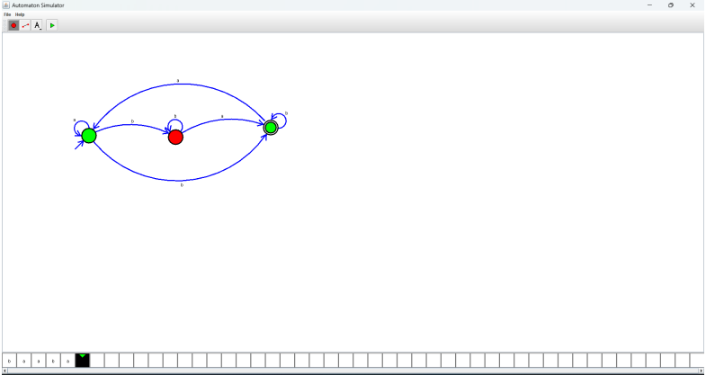

**RESULT:** Hence designing NFA using a simulator to accept the string that start and end with different symbols